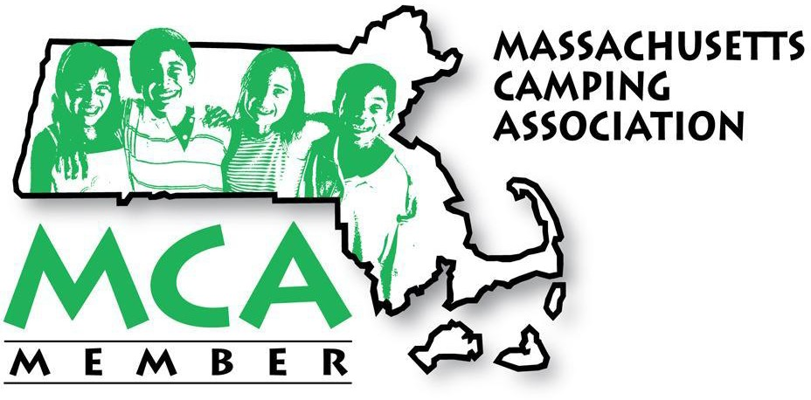
MEMBERSHIP APPLICATION

Please mail to:
Joanna Lenahan Girl Scouts of Eastern Massachusetts
111 East Grove Street Middleboro, MA 02346

We are Stronger Together and the MCA needs every camp's voice and financial support as we continue our work in the best interest of your children’s summer camp experience. Please support our critical work by joining, or making a donation of financial support.

Payment: Please go online to pay your dues (http://masscamping.org/join-mca/how-to-join/) or make checks out to - Massachusetts Camping Association
Camp Name:
Camp Mailing Address:
City: State: Zip:
Email:
Phone Number:
Main Contact:
Main Contact Email:
If you are an organization operating multiple camps please send a listing of all camps with contact information.

Description | Amount
For annual membership 01/23 - 12/23, we are asking camps to pay based on your 2022 financials. Individual Camps with Operating Budget Over $1,000,000  Individual Camps with Operating Budget $500,000 - $999,999 Individual Camp with Operating Budget Up to $499,999 Organizational Camps (includes memberships up to 4 camps)  If you need additional assistance with membership dues , please contact mcaboard@gmail.com | $1200  $ 800  $ 550  $1200 for up to 4 camps, plus $150 each additional camp
2023 Dues | $
Additional Donation (Please consider an additional donation toward our current educational and legislative efforts) | $
Total | $
- Membership questions: Please contact Joanna Lenahan, MCA Secretary at mcaboard@gmail.com.
- Want to become more involved with the MCA Board? Contact Matt Scholl, MCA President at mscholl@bccymca.org.

MCA is committed to being the voice of organized camping in Massachusetts but can only do this with the dedication and contributions of the Massachusetts Camping Community. We thank you for your support.

"STRONGER TOGETHER""www.masscamping.org"

